Agile Scrum Meetings
1. Sprint Planning Meeting
Definition
Sprint Planning is the first meeting conducted at the beginning of every sprint. During this meeting, the Scrum Team decides what work will be completed in the upcoming sprint and creates a plan to achieve the sprint goal.
Purpose
- Define the Sprint Goal.
- Select Product Backlog items to work on.
- Estimate and distribute tasks among team members.
- Create a Sprint Backlog.
Participants
- Product Owner
- Scrum Master
- Development Team
Activities Performed
- Review and prioritize Product Backlog items.
- Discuss business requirements.
- Estimate effort for each task.
- Break user stories into smaller tasks.
- Finalize the Sprint Backlog.
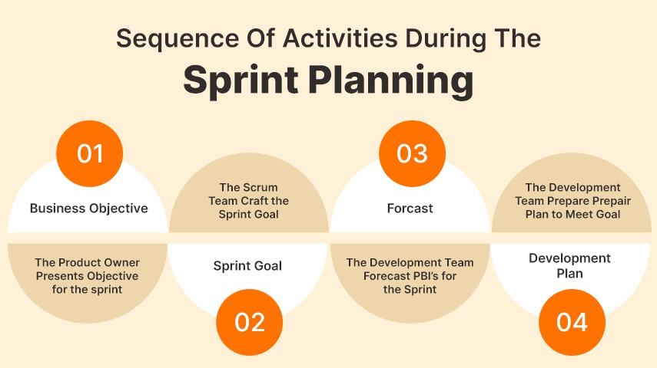
Output
- Sprint Goal
- Sprint Backlog
- Task assignments and development plan
Benefits
- Provides a clear roadmap for the sprint.
- Ensures the team understands project priorities.
- Improves collaboration and planning.
- Reduces confusion during development.
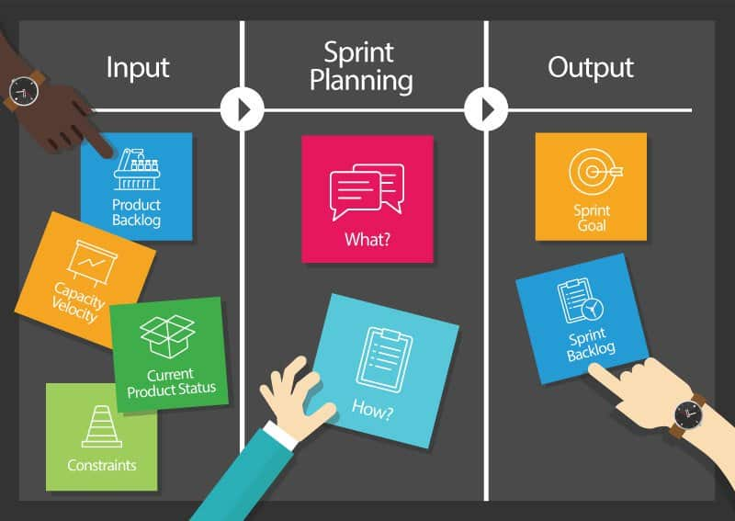
2. Daily Stand-up Meeting (Daily Scrum)
Definition
The Daily Stand-up Meeting is a short meeting held every day during the sprint. It helps team members share progress, discuss current work, and identify any obstacles affecting their tasks.
Purpose
- Monitor daily progress.
- Improve team communication.
- Identify blockers quickly.
- Keep everyone aligned with the Sprint Goal.
Participants
- Development Team (mandatory)
- Scrum Master
- Product Owner (optional)
Duration
- 15 minutes
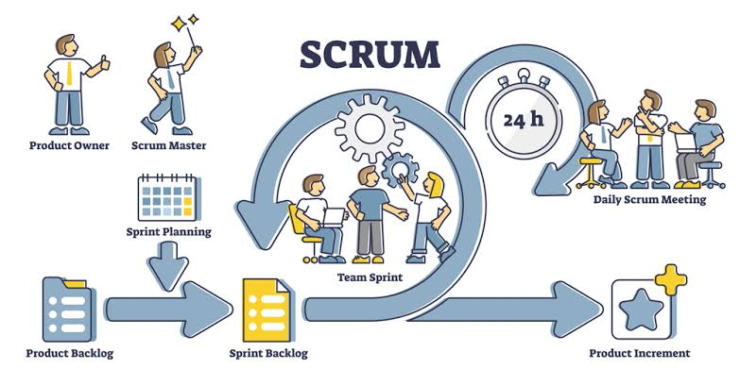
Typical Questions Answered
Each team member answers three questions:
- What did I complete yesterday?
- What will I work on today?
- Are there any blockers or challenges?
Benefits
- Encourages transparency.
- Detects issues early.
- Keeps the project on schedule.
- Improves team coordination.

3. Sprint Retrospective Meeting
Definition
The Sprint Retrospective is conducted at the end of every sprint after the Sprint Review. The team reflects on the completed sprint and identifies ways to improve processes for the next sprint.
Purpose
- Review the team's performance.
- Identify what went well.
- Discuss challenges faced.
- Plan improvements for future sprints.
Participants
- Product Owner
- Scrum Master
- Development Team
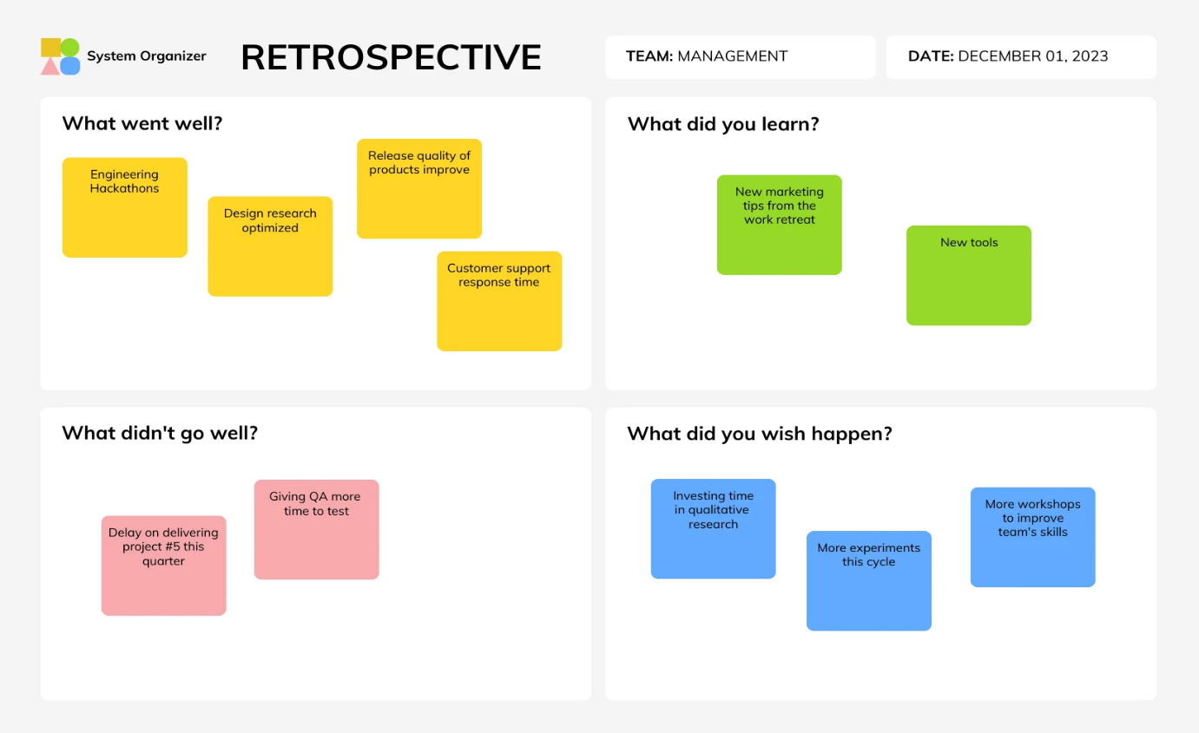
Activities Performed
- Discuss successful practices.
- Identify problems encountered.
- Analyze root causes of issues.
- Suggest process improvements.
- Create action items for the next sprint.

Typical Discussion Points
- What went well?
- What did not go well?
- What can we improve?
- Which actions should be implemented in the next sprint?
Output
- List of improvement actions.
- Updated working practices.
- Better collaboration strategy for future sprints.
Benefits
- Promotes continuous improvement.
- Enhances team productivity.
- Improves communication.
- Reduces repeated mistakes.
- Strengthens teamwork.

